**Noise pollution monitoring**

# *Introduction:*

*Noise pollution, an often underestimated and pervasive environmental issue, has a profound impact on the quality of life in urban and industrial areas. It arises from a multitude of sources, including traffic, construction, industrial operations, and even recreational activities. The intrusive and disruptive nature of noise pollution can lead to heightened stress levels, sleep disturbances, reduced productivity, and adverse health effects, making it a pressing concern for both individuals and communities.*

*In response to the growing challenges posed by noise pollution, the field of noise pollution monitoring has gained prominence. This discipline involves the systematic measurement, assessment, and management of noise levels in various environments. Through the deployment of advanced sensor technology, data collection methods, and analytical tools, noise pollution monitoring aims to provide actionable insights, support regulatory compliance, and facilitate the implementation of noise reduction strategies.*

*This exploration delves into the intricate realm of noise pollution monitoring, shedding light on its methodologies, hardware components, problem statements, solutions, and the broader implications for improving living conditions and environmental sustainability. By comprehensively understanding noise pollution monitoring, we can work towards creating quieter, healthier, and more harmonious urban and industrial landscape.*

***Abstract:***

*Noise pollution is a growing concern in urban areas, affecting the well-being of residents and the quality of life. This abstract outlines an innovative noise pollution monitoring system designed to address this issue. The proposed system combines advanced sensor technology, data analytics, and real-time reporting to offer a comprehensive solution for monitoring noise pollution in urban environments.*

*Key components of the system include an array of strategically placed noise sensors capable of capturing real-time audio data. These sensors transmit data to a central server, where it is processed and analyzed. Machine learning algorithms are employed to differentiate between various sources of noise, such as traffic, construction, and industrial activities, allowing for more precise identification of problem areas.*

*The system’s user-friendly interface provides accessible information to both local authorities and the public. Decision-makers can use the data to implement noise abatement measures, while citizens can access noise levels in their vicinity via a dedicated mobile app.*

*This innovative noise pollution monitoring system not only enhances environmental quality but also empowers communities to actively engage in noise pollution mitigation efforts. As urbanization continues to rise, the importance of effective noise monitoring and control cannot be overstated.*

*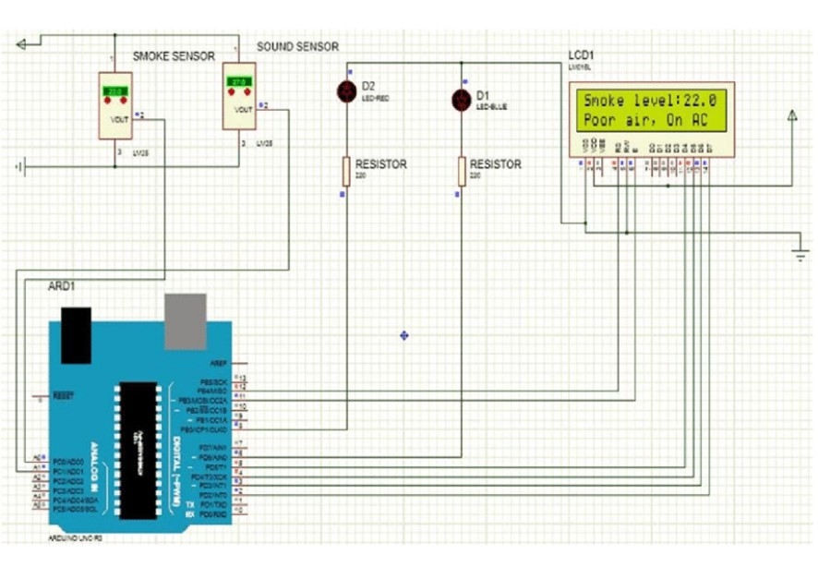****Design:***

***IOT based Noise Monitoring system:***

*An IoT-based noise pollution monitoring system uses sensors to detect and measure noise levels in real-time, sending data to a central server for analysis and visualization. Key components include:*

* ***Noise Sensors:*** *These can be microphones or specialized noise sensors that capture sound levels. They should be strategically placed in different locations to cover the area of interest.*
* ***Microcontroller/Embedded System:*** *Typically, a microcontroller (e.g., Arduino or Raspberry Pi) is used to interface with the sensors, collect data, and transmit it to the server.*
* ***Connectivity:*** *IoT devices usually communicate through Wi-Fi, cellular, or other wireless protocols to transmit data to a cloud server or local network.*
* ***Cloud Server:*** *Data is sent to a central server for storage, analysis, and visualization. Cloud platforms like AWS, Azure, or Google Cloud are commonly used for this purpose.*
* ***Data Analysis:*** *Software on the server processes the data, calculates noise levels, and may perform additional analysis such as identifying peak noise events or trends over time.*
* ***Visualization****: The noise data can be displayed on a web-based dashboard or mobile app for easy monitoring by stakeholders or the public.*
* ***Alerting System:*** *In some cases, the system can be configured to send alerts or notifications when noise levels exceed predefined thresholds.*
* ***Data Storage:*** *Historical data is often stored for analysis and trend monitoring.Such systems are valuable for urban planning, environmental monitoring, and ensuring compliance with noise regulations. They can help authorities and communities address noise pollution issues effectively.*

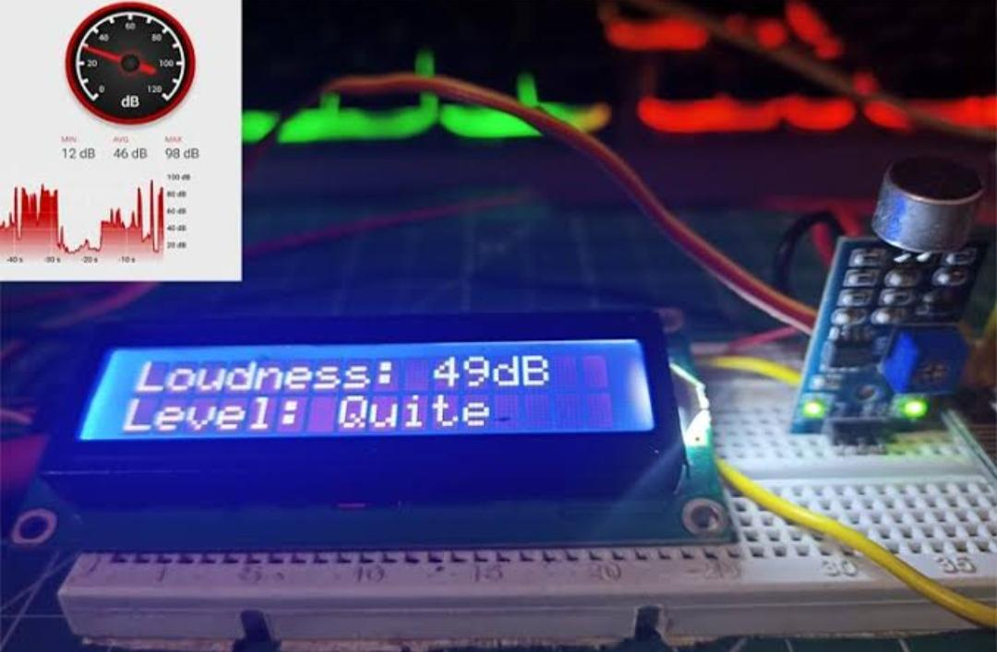

***How it works?***

*An IoT-based noise pollution monitoring system works by utilizing sensors, data communication, and cloud-based analytics to monitor and analyze noise levels in real-time. Here’s a simplified overview of how it functions:*

* *Noise Sensors: The system comprises noise sensors or microphones strategically placed in the area of interest, such as urban areas, industrial zones, or residential neighborhoods.*
* *Data Collection: These sensors continuously collect ambient noise data, including sound intensity (in decibels), frequency, and sometimes other environmental factors like temperature and humidity.*
* *Data Processing: The collected noise data is processed locally within the sensors or at a nearby gateway device to reduce noise interference and filter out irrelevant information.*
* *Data Transmission: Processed data is then transmitted to a central hub or cloud server using various communication methods like Wi-Fi, cellular networks, or LPWAN (Low Power Wide Area Network) technologies like LoRa or NB-IoT.*
* *Cloud Storage: Data received from multiple sensors is stored securely in the cloud. This allows for centralized data management and access from anywhere with an internet connection.*
* *Real-Time Monitoring: Users, such as environmental agencies or city authorities, can access a web-based dashboard or mobile app to monitor noise levels in real-time. Alerts can be set up to notify them if noise levels exceed predefined thresholds.*
* *Data Analysis: The system can perform data analysis and generate reports. Machine learning algorithms may be used to identify patterns, trends, and potential sources of noise pollution. Historical data can also be used for long-term analysis.*
* *Visualization: Noise pollution data can be presented through user-friendly graphs, maps, and visualizations, making it easier for stakeholders to understand and interpret the information.*
* *Remote Control: Some systems allow for remote control of certain devices, such as adjusting sound barriers or redirecting traffic in response to noise pollution events.*
* *Feedback and Decision-Making: Decision-makers can use the insights gained from the system to implement noise mitigation measures, enforce noise regulations, and make informed urban planning decisions to reduce noise pollution.*

*Overall, an IoT-based noise pollution monitoring system provides a comprehensive and data-driven approach to understanding and managing noise pollution in urban environments. It helps improve the quality of life for residents and supports environmental sustainability efforts.*

***Conclusion:***

*In conclusion, an IoT-based noise pollution monitoring system offers numerous benefits for managing and mitigating noise pollution. By leveraging sensors, data analytics, and connectivity, it enables real-time monitoring, data collection, and analysis of noise levels in urban areas. This system provides valuable insights for city planners, environmental agencies, and residents to take informed actions in reducing noise pollution and improving overall quality of life. Additionally, it contributes to the development of smarter and more sustainable cities by enhancing environmental awareness and promoting noise pollution control measures.*

**Thank you…**